|  |  |
| --- | --- |
| **TEAM ID** | **PNT2022TMID10261** |
| **PROJECT NAME** | **Personal Assistance for Seniors Who Are Self-Reliant** |

Sprint 1

The AIM of Sprint 1 is SIMULATION CREATION. Duration : 6 days

In this Sprint 1 we have found out what the elderly people used to and suffer in Alzheimer disease .So the we had decided that we should find the solution of four different Ideas from our teammates

1. Our teammate Ramesh P, Medicine Remainder for Alzheimer disease person to keep an instant remainder for their medicine that is taken by them and keep them on track of their medicine taken.
2. Our teammate Prasath V,A Medicine Remainder for elderly person that are elderly person in home and Hospital and keep them check in Medicine that are forgotten by Caretaker and Person around them.
3. Our teammate Praveen Kumar A, A Stock Remainder of Medicine for Elderly Person and keep the medicine in check every time if the medicine prolonged for another week and have the refilled alarm for the medicine that need to taken.
4. Our teammate Maria Antony B ,A Scan of medicine to zoom and see the medicine those are taken by the elderly person and keep in check of medication of elderly person. If needed the medication can be upload the App.

By considering all the ideas that are given teammate .We conclude that are of decision made by teammate is make a combine idea of Medicine Remainder App that feature of scanning of medicine , medicine remainder at correct timing, Stock remainder.

What we should complete in sprint 1?The Issue collected from user

USN 1:As a user, I want to take Medicines on time and monitor my health USN 2:As a user, I want to take my tablets on time by voice command

USN 3:As a user, I need to take my medicine and I am not able see the dosage of medicine properly

USN 4:As a user, Sometimes my medicine aren’t in stock and I usually forget the Stock of my medication.

REQUIRED MATERIALS:

1. RTC DS3231 module
2. 16x2 LCD Display
3. Buzzer
4. Led(any color)
5. Breadboard
6. Push Buttons
7. 10K Potentiometer
8. 10K,1K Resistors
9. Jumper Wires
10. Arduino Uno Simulation:

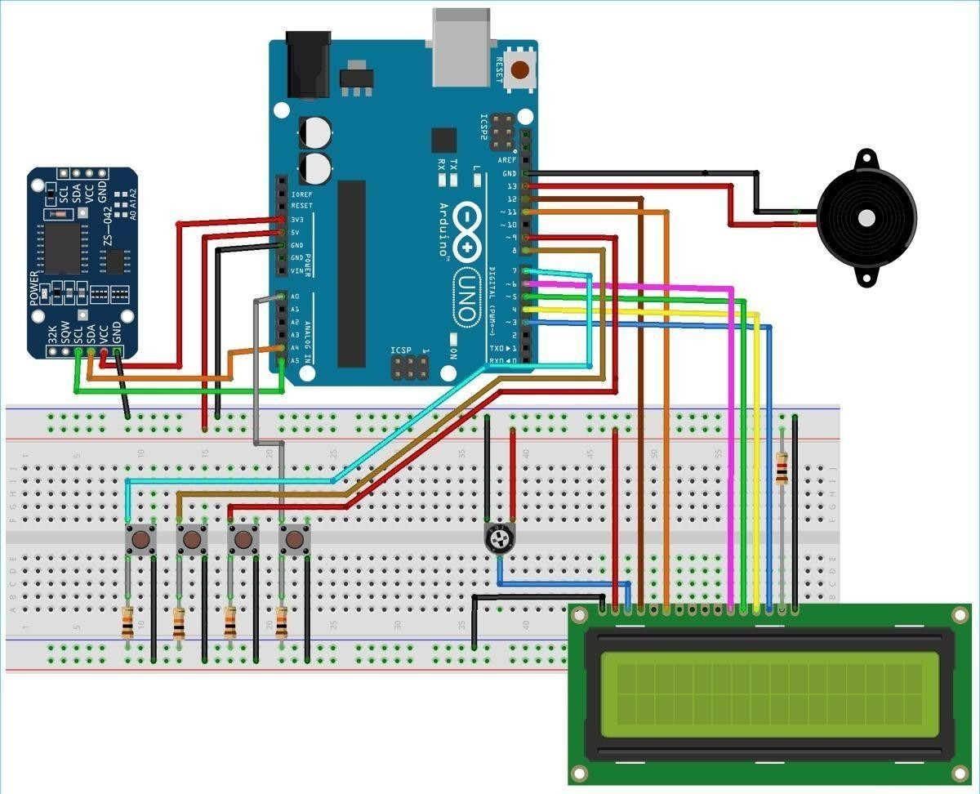

Code:

//Medicine Reminder using Arduino Uno

// Reminds to take medicine at 8am, 2pm, 8pm

/* The circuit:

LCD RS pin to digital pin 12

LCD Enable pin to digital pin 11 LCD D4 pin to digital pin 5

LCD D5 pin to digital pin 4 LCD D6 pin to digital pin 3 LCD D7 pin to digital pin 2 LCD R/W pin to ground

LCD VSS pin to ground LCD VCC pin to 5V 10K resistor:

ends to +5V and ground

wiper to LCD VO pin (pin 3)*/ #include <LiquidCrystal.h> #include <Wire.h>

#include <RTClib.h> #include <EEPROM.h> int pushVal = 0; int val;

int val2;

int addr = 0; RTC_DS3231 rtc;

const int rs = 12, en = 11, d4 = 5, d5 = 4, d6 = 3, d7 = 2; // lcd pins

LiquidCrystal lcd(rs, en, d4, d5, d6, d7); #define getWellsoon 0

#define HELP_SCREEN 1

#define TIME_SCREEN 2

//bool pushPressed; //flag to keep track of push button state

int pushpressed = 0;

const int ledPin = LED_BUILTIN; // buzzer and led pin int ledState = LOW;

int Signal = 0;

int buzz = 13;

int push1state, push2state, push3state, stopinState = 0; //

int push1Flag, push2Flag, Push3Flag = false; // push button flags int push1pin = 9;

int push2pin = 8; int push3pin = 7; int stopPin = A0;

int screens = 0; // screen to show

int maxScreen = 2; // screen count bool isScreenChanged = true;

long previousMillis = 0;

long interval = 500; // buzzing interval unsigned long currentMillis;

long previousMillisLCD = 0; // for LCD screen update long intervalLCD = 2000; // Screen cycling interval unsigned long currentMillisLCD;

// Set Reminder Change Time

int buzz8amHH = 8; // HH - hours ##Set these for reminder time in 24hr Format

int buzz8amMM = 00; // MM - Minute

int buzz8amSS = 00; // SS - Seconds

int buzz2pmHH = 14; // HH - hours

int buzz2pmMM = 00; // MM - Minute

int buzz2pmSS = 00; // SS - Seconds

int buzz8pmHH = 20; // HH - hours

int buzz8pmMM = 00; // MM - Minute

int buzz8pmSS = 00; // SS - Seconds

int nowHr, nowMin, nowSec; // to show current mm,hh,ss

// All messeges

void gwsMessege(){ // print get well soon messege lcd.clear();

lcd.setCursor(0, 0);

lcd.print("Stay Healthy :)"); // Give some cheers lcd.setCursor(0, 1);

lcd.print("Get Well Soon :)"); // wish

}

void helpScreen() { // function to display 1st screen in LCD lcd.clear();

lcd.setCursor(0, 0); lcd.print("Press Buttons"); lcd.setCursor(0, 1); lcd.print("for Reminder...!");

}

void timeScreen() { // function to display Date and time in LCD screen DateTime now = rtc.now(); // take rtc time and print in display

lcd.clear();

lcd.setCursor(0, 0); lcd.print("Time:"); lcd.setCursor(6, 0); lcd.print(nowHr = now.hour(), DEC); lcd.print(":");

lcd.print(nowMin = now.minute(), DEC); lcd.print(":");

lcd.print(nowSec = now.second(), DEC); lcd.setCursor(0, 1);

lcd.print("Date: ");

lcd.print(now.day(), DEC);

lcd.print("/"); lcd.print(now.month(), DEC); lcd.print("/");

lcd.print(now.year(), DEC);

}

void setup() {

Serial.begin(9600); // start serial debugging

if (! rtc.begin()) { // check if rtc is connected Serial.println("Couldn't find RTC");

while (1);

}

if (rtc.lostPower()) {

Serial.println("RTC lost power, lets set the time!");

}

// rtc.adjust(DateTime(F( DATE ), F( TIME ))); // uncomment this to set the current time and then comment in next upload when u set the time

rtc.adjust(DateTime(2019, 1, 10, 7, 59, 30)); // manual time set

lcd.begin(16, 2);

lcd.clear(); lcd.setCursor(0, 0);

lcd.print("Welcome To"); // print a messege at startup

lcd.setCursor(0, 1); lcd.print("Circuit Digest"); delay(1000);

pinMode(push1pin, INPUT); // define push button pins type

pinMode(push2pin, INPUT); pinMode(push3pin, INPUT); pinMode(stopPin, INPUT); pinMode(ledPin, OUTPUT); delay(200); Serial.println(EEPROM.read(addr));

val2 = EEPROM.read(addr); // read previosuly saved value of push button to start from where it was left previously

switch (val2) { case 1:

Serial.println("Set for 1/day"); push1state = 1;

push2state = 0;

push3state = 0;

pushVal = 1; break;

case 2:

Serial.println("Set for 2/day"); push1state = 0;

push2state = 1;

push3state = 0;

pushVal = 2; break;

case 3:

Serial.println("Set for 3/day"); push1state = 0;

push2state = 0;

push3state = 1;

pushVal = 3; break;

}

}

void loop() {

push1(); //call to set once/day

push2(); //call to set twice/day

push3(); //call to set thrice/day

if (pushVal == 1) { // if push button 1 pressed then remind at 8am

at8am(); //function to start uzzing at

8am

}

else if (pushVal == 2) { // if push button 2 pressed then remind at 8am and 8pm

at8am();

at8pm(); //function to start uzzing at

8mm

}

else if (pushVal == 3) { // if push button 3 pressed then remind at 8am and 8pm

at8am();

at2pm(); //function to start uzzing at

8mm

at8pm();

}

currentMillisLCD = millis(); // start millis for LCD screen switching at defined interval of time

push1state = digitalRead(push1pin); // start reading all push button pins

push2state = digitalRead(push2pin); push3state = digitalRead(push3pin); stopinState = digitalRead(stopPin);

stopPins(); // call to stop buzzing

changeScreen(); // screen cycle function

}

// push buttons

void push1() { // function to set reminder once/day if (push1state == 1) {

push1state = 0;

push2state = 0;

push3state = 0;

// pushPressed = true;

EEPROM.write(addr, 1);

Serial.print("Push1 Written : "); Serial.println(EEPROM.read(addr)); // for debugging

pushVal = 1; //save the state of push

button-1

lcd.clear(); lcd.setCursor(0, 0); lcd.print("Reminder set "); lcd.setCursor(0, 1); lcd.print("for Once/day !"); delay(1200);

lcd.clear();

}

}

void push2() { //function to set reminder twice/day if (push2state == 1) {

push2state = 0;

push1state = 0;

push3state = 0;

// pushPressed = true; EEPROM.write(addr, 2);

Serial.print("Push2 Written : "); Serial.println(EEPROM.read(addr)); pushVal = 2;

lcd.clear(); lcd.setCursor(0, 0); lcd.print("Reminder set "); lcd.setCursor(0, 1); lcd.print("for Twice/day !");

delay(1200); lcd.clear();

}

}

void push3() { //function to set reminder thrice/day if (push3state == 1) {

push3state = 0;

push1state = 0;

push2state = 0;

// pushPressed = true; EEPROM.write(addr, 3);

Serial.print("Push3 Written : "); Serial.println(EEPROM.read(addr)); pushVal = 3;

lcd.clear(); lcd.setCursor(0, 0); lcd.print("Reminder set "); lcd.setCursor(0, 1);

lcd.print("for Thrice/day !"); delay(1200);

lcd.clear();

}

}

void stopPins() { //function to stop buzzing when user pushes stop push button

if (stopinState == 1) {

// stopinState = 0;

// pushPressed = true;

pushpressed = 1; lcd.clear(); lcd.setCursor(0, 0); lcd.print("Take Medicine "); lcd.setCursor(0, 1); lcd.print("with Warm Water"); delay(1200);

lcd.clear();

}

}

void startBuzz() { // function to start buzzing when time reaches to defined interval

// if (pushPressed == false) { if (pushpressed == 0) {

Serial.println("pushpressed is false in blink"); unsigned long currentMillis = millis();

if (currentMillis - previousMillis >= interval) {

previousMillis = currentMillis; // save the last time you blinked the

LED

Serial.println("Start Buzzing");

if (ledState == LOW) { // if the LED is off turn it on and vice-versa:

ledState = HIGH;

} else { ledState = LOW;

}

digitalWrite(ledPin, ledState);

}

}

else if (pushpressed == 1) { Serial.println("pushpressed is true"); ledState = LOW;

digitalWrite(ledPin, ledState);

}

}

void at8am() { // function to start buzzing at 8am DateTime now = rtc.now();

if (int(now.hour()) >= buzz8amHH) {

if (int(now.minute()) >= buzz8amMM) { if (int(now.second()) > buzz8amSS) {

///////////////////////////////////////////////////// startBuzz();

/////////////////////////////////////////////////////

}

}

}

}

void at2pm() { // function to start buzzing at 2pm DateTime now = rtc.now();

if (int(now.hour()) >= buzz2pmHH) {

if (int(now.minute()) >= buzz2pmMM) { if (int(now.second()) > buzz2pmSS) {

/////////////////////////////////////////////////// startBuzz();

//////////////////////////////////////////////////

}

}

}

}

void at8pm() { // function to start buzzing at 8pm DateTime now = rtc.now();

if (int(now.hour()) >= buzz8pmHH) {

if (int(now.minute()) >= buzz8pmMM) { if (int(now.second()) > buzz8pmSS) {

///////////////////////////////////////////////////// startBuzz();

/////////////////////////////////////////////////////

}

}

}

}

//Screen Cycling

void changeScreen() { //function for Screen Cycling

// Start switching screen every defined intervalLCD

if (currentMillisLCD - previousMillisLCD > intervalLCD) // save the last time you changed the display

{

previousMillisLCD = currentMillisLCD; screens++;

if (screens > maxScreen) {

screens = 0; // all screens over -> start from 1st

}

isScreenChanged = true;

}

// Start displaying current screen

if (isScreenChanged) // only update the screen if the screen is changed.

{

isScreenChanged = false; // reset for next iteration switch (screens)

{

case getWellsoon:

gwsMessege(); // get well soon message break;

case HELP_SCREEN:

helpScreen(); // instruction screen break;

case TIME_SCREEN:

timeScreen(); // to print date and time break;

default:

//NOT SET.

break;

}

}

}

The **conclusion** of Sprint 1 we have analyst all the problems that are faced by the elderly people and created the dry code simulation that are given by ideas by our teammates.